Through the Forests of Threnody
Ryan Koenig
22201444
Game Development Assignment 2

Introduction
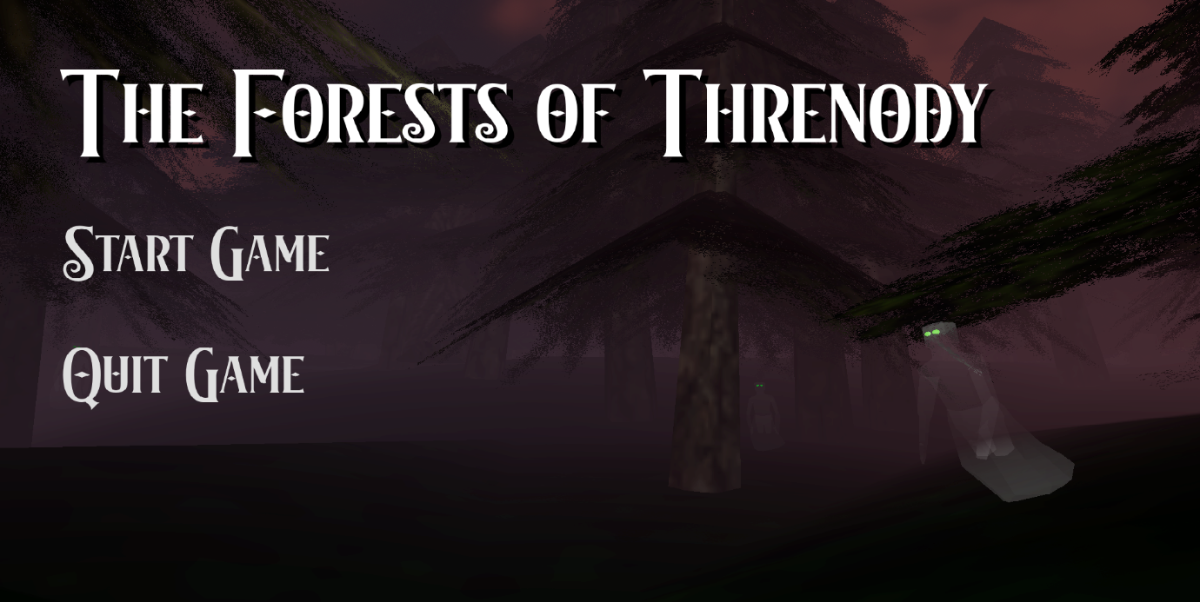
This game is a combination of the popular mobile game, ‘Into the Dead’ and the novella ‘Shadows for Silence in the Forests of Hell.’ The game’s corridor theme comes from the small section of forest to run through, where the player is limited on both sides and must dodge between trees and Shadows in order to make it to the end and get a payment. As the player progresses through the game the space they have to maneuver will be reduced, the Shadows will become more frequent, and the distance to run will get longer. To combat this, weapons and tools can be bought to fight back against the Shadows or conceal from them.

Features
- Procedural level generation based on various difficulty levels
  - Difficulty increases as the player completes levels and earns money, so the player becomes more powerful to match the increased challenge.
- A shop where you can buy various themed items, inspired by Brandon Sanderson’s writing using metals as a way to interact with the magic systems in his stories.
  - Two active abilities:
    - A silver weapon, which can be swung to kill one or more Shadows, but consumes some silver from the weapon, making its use precious.
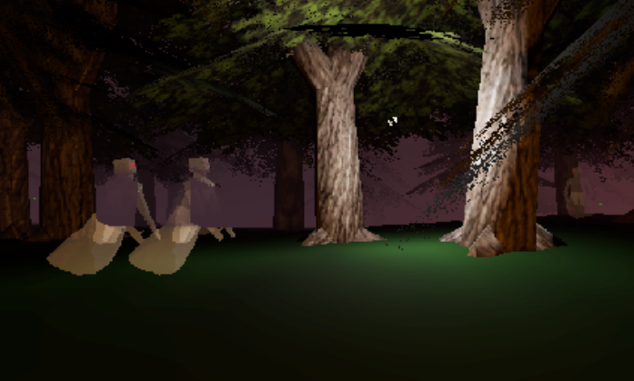
    - A throwable magnesium grenade, which draws the Shadows away. Highly effective when used carefully, but expensive, encouraging the player to plan ahead and be mindful of the world and their tools.

  - Two passive abilities:
    - A pewter upgrade to your silver weapons which insulates the more expensive silver weapon. Attacks will consume pewter before silver.
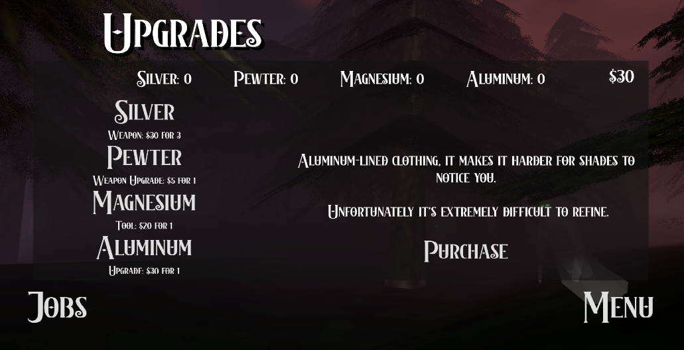
    - A permanent aluminum armor upgrade that reduces the range the Shadows will notice you, giving you more time to slip between Shadows.
- Fully functional mobile controls
- Hand-created and rigged Shadow model, with eye colors that reflect aggression / alert state
- Atmospheric forests to run through. With an old PlayStation style, using the environment from the Sky3D addon alongside automatic and performant tree placement from the Proton Scatter addon.

Challenges
This game presented quite a few challenges, even with me leaning on past experience in Godot game development. UIs, modelling, sound, and especially procedural stage generation all took learning and adapting to make an enjoyable game.

Being inexperienced with UIs, they posed an extra challenge. The game’s menus required lots of interactive aspects, buttons, and changing text based on the player’s state and choices. After the first implementation, every menu was its own scene and almost every button had its own script. With more practice, I was able to consolidate all the menus, and most of the scripts, together into one scene and a handful of scripts. This significantly increased the visuals and ease of use of the menu. With more development, the design of the interactable elements and backgrounds could also be altered to better match the theme and be more intuitive to use.
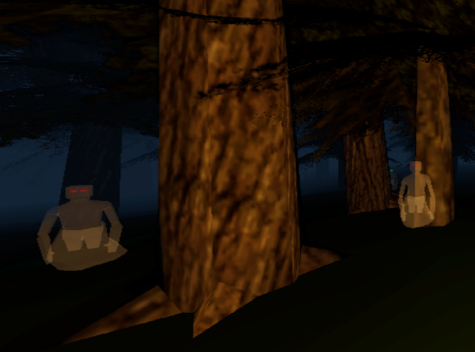
Modelling and sound design were entirely new areas for me. In previous projects, such as my work during the GMTK 2025 Game Jam, I relied entirely on pre-made game assets. For this project, I followed several modelling tutorials and spent significant time experimenting with blender before producing a fully rigged Shadow model that matched the descriptions from the novella.

The semi-procedural level generation was the greatest challenge in the game. The level generation is the core point of interest for this game. Where getting the theme of the ‘Forests of Hell’ right, as well as providing an interesting and unique challenge and game loop, are all dependent on the level the player runs through. Using addons like Proton Scatter and Sky3D made the process easier, as I did not have to worry about individually placing and optimizing props and editing environments. Getting the world generation to a good position took lots of development, refinement and experimentation.

One of the most difficult parts of the procedural generations was having the Shadows spawn in the right place, on ground. In the final product, the game uses raycasts. It is likely more performant to transfer exact array coordinates of the ground into the ‘Enemy Spawner’ scene; however, learning how to use 3D raycasts will be an important skill for future games.

Improvements
One of the largest improvements I would make to the game is major additions to the progression of the game. As the game is now, it has a limited progression system. The skeleton of a rogue-like item-based player progression and a ramping difficulty are there but need more depth. Incorporating more items in the shops with permanent upgrades, additional weapons, and stat increases would provide more goals for the player to work towards. All while added features like NPC blockades, city walls encroaching on your running space, river crossings and more would provide opportunity for careful tool use and novel difficulty increases.

While often difficult to incorporate with a rogue-like game, an overarching story through each run would also contribute significantly to the player’s experience in this game. A story would connect the game better to the novella and help satisfy a reader of the novella’s desire for an in-depth exploration of the world they only saw a tiny glimpse of. A story could also help incorporate a story into the game, explaining to players who haven’t read the tutorial why things are the way they are, and slowly introducing new mechanics and features.

Sources:
- Tree, terrain, grass assets from PorkBellyGames: itch.io
  - While these are paid assets, I had previously purchased these for the 2025 GMTK Game Jam.
- Sky3D, a free Godot addon by TokisanGames: GitHub
- Proton Scatter, a free Godot addon by HungryProton: GitHub
- Blur shader by shellrider: godotshaders
- Buttons for mobile by Leo-red: itch.io
- Sounds:
  - Dirtmouth, Hollow Knight Soundtrack - Christopher Larkin
  - Clover Dancers, Silksong Soundtrack - Christopher Larkin
  - Ghost Whispers - Freesound Community
  - “Fast Sword Whoosh” - Mixkit

